The Dangers of Smoking Cigarettes for Smokers
What's in a Cigarette & Disease: Chemicals, Cancer and Heart Disease
The main ingredient in cigarettes is tobacco. Tobacco is a green, leafy plant that is grown in warm climates. Farmers use many chemicals to grow tobacco. They use fertilizers to make the soil rich and insecticides to kill the insects that eat the tobacco plant.
After the tobacco plants are picked, they are dried, and machines break up the leaves into small pieces. Artificial flavorings and other chemicals are added. Some chemicals are put in cigarettes to keep them burning; otherwise, they would go out.
There are over 4,000 chemicals in cigarettes. 51 of them are known to be carcinogenic. A carcinogen is something that causes cancer. Cancer is a disease that often kills those who have it. There are many types of cancer: breast, lung, larynx, stomach, prostrate, kidney, leukemia (cancer of the blood), etc. In all kinds of cancer, the cells keep dividing and forming new, abnormal cells. These cells are not normal or healthy.
Our bodies are made up of thousands of cells. In a healthy person, new cells are made only when the body needs them. In a person with cancer, the abnormal cells destroy the normal cells, invading them like an army. If cells divide when new cells are not needed, a growth or hard mass forms. It could be small like a pea or large like a grapefruit. A cancerous growth is called a malignant tumor.
Cancer usually kills a person when it spreads to other parts of the body. Sometimes cancer cells break away from a malignant tumor and find their way into the bloodstream. They travel to another part of the body or organ like a kidney or lung. There they start multiplying and dividing and form new cancerous tumors. For example, if a woman who has a malignant tumor in her breast does not have it removed while it is small, part of the tumor might break away and go into her bloodstream. From there it may travel to her brain and give her brain cancer.
Chemicals in cigarettes and cigarette smoke are known to cause not only cancer but also other serious health problems. Many of the chemicals are poisonous. If a person ate one pack of cigarettes, he/she would die.

Familiar Chemicals in Cigarettes
Chemical | Found in:
carbon monoxide | car exhaust
nicotine | bug sprays
tar | material to make roads
arsenic | rat poison
ammonia | cleaning products
hydrogen cyanide | gas chamber poison
cyanide | deadly poison
acetone | nail polish remover
butane | cigarette lighter fluid
DDT | insecticides
formaldehyde | to preserve dead bodies
sulfuric acid | car batteries
cadmium | used to recharge batteries
freon | damages earth's ozone layer
geranic acid | a fragrance
methoprene | a pesticide
maltitol | a sweetener not permitted to be used in foods in the U.S.
Sources: Dr. Joel Dunnington, Tobacco Almanac, Revised, May 1993.
Three of the most widely known chemicals are nicotine, tar, and carbon monoxide. Nicotine is a strong poisonous drug. It is the main ingredient in insecticides or bug sprays. In its pure form, just one drop on a person's tongue would kill him/her.
Tar is the oily material which remains after tobacco passes through the filter. When a smoker inhales, a lot of the tar sticks to and blackens the lungs.
Carbon monoxide is a poisonous gas. A smoker inhales this gas which is also found in the exhaust of a car. This gas interferes with our respiratory (breathing) and circulatory (heart, arteries, and veins) systems. When we breathe in air through our nose and mouth, the air passes down the windpipe (trachea) and bronchial tubes into the lungs. The cilia which are made up of small hairs and mucous (a sticky fluid also found in the nose) help to clean this air as it moves down and into the lungs. The cilia remove small pieces of dirt, dust, and germs.
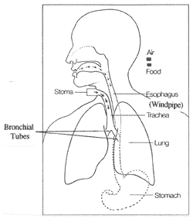
Credit: Cancer of the Larynx, National Cancer Institute, NIH, 2/92
We each have two lungs. They are protected by the ribs and separated by the heart. In a healthy nonsmoker, the lungs are made up of soft, spongy, pinkish-gray tissue. 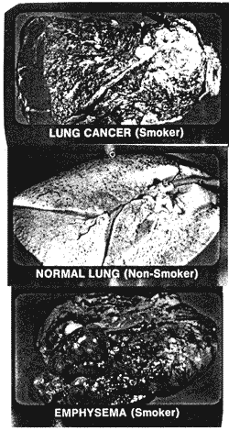
The lungs also have hundreds of air sacs that fill with air when we inhale or breathe in. They are elastic like rubber bands.
One of the jobs of the lungs is to take oxygen in from the air. This oxygen is carried in the blood to the heart. The heart pumps the oxygen rich blood throughout the body by arteries. Arteries are large tubes with thick, strong walls. Oxygen is used by all cells of the body to do their work.
The lungs also must get rid of carbon dioxide which is the waste product of the cells' work. When we exhale, breathe out, we are getting rid of the carbon dioxide from the body.
When a person smokes cigarettes, the carbon monoxide in the smoke gets into his/her blood stream. This reduces the amount of oxygen going to the heart. In addition, the chemicals in cigarette smoke narrow the walls of the arteries. With less oxygen passing through the arteries, the heart must work harder. Blood pressure also goes up.

